**Final Project Report**

## NAME & STUDENT-ID

Venkata Sivannarayana Pavuluri (00832087)

## PROJECT TITLE:

Comparative Analysis of Pre-trained Encoders for Emotion Recognition

## COURSE:

Natural Language Processing (DSCI-6004-02)

# **Abstract**

The project's goal is to identify and classify the underlying emotions in the text. It highlights how to improve emotion recognition in text by using BERT and RoBERTa Pre-trained Transformer models. The study is significant because it has the potential to advance sentiment analysis in a number of applications, which will benefit the expanding field of natural language processing (NLP). Comparing how well the pre-trained models BERT and RoBERTa analyze the text's emotions is the main goal. By concurrently conditioning on both left and right context in all layers, BERT is intended to pretrain deep bidirectional representations from unlabelled text. Therefore, state-of-the-art models for a variety of applications can be created by fine-tuning the pre-trained BERT model with just one extra output layer.

**Keywords:** BERT, RoBERTa, Emotion Detection, NLP, Sentiment Analysis, Transformers.

# **Introduction**

The comprehension of human emotions conveyed in text has become a crucial difficulty in the quickly changing field of Natural Language Processing (NLP). In a variety of fields, from social media research and customer feedback interpretation to mental health applications, the capacity to recognize sentiment and emotional complexity is essential. Strong emotion recognition models are becoming more and more necessary as textual data volumes keep growing. In order for people to exist or to be fully formed, emotions are essential.

They give onlookers information about our present situation and welfare. It is necessary for companies and individuals to recognize the many emotions that people express in order to tailor their recommendations to each customer's unique needs and enable them to offer the best services possible. A natural language processing task called sentiment analysis is used to determine the underlying emotional tone—whether positive, negative, or neutral—of a given remark.

Going a step further, emotion categorization looks into the underlying semantics of a statement to determine the emotion attached to it. Emotions include concern, rage, and sadness, among others. The multi-label emotion classification issue associates an instance with a subset of labels, in contrast to the typical single-label emotion classification problem, which associates only one emotion label from a finite set of emotion labels with a data instance. The goal of multi-label emotion categorization, a somewhat difficult endeavor, is to comprehend the meaning of documents for various dimensions, or emotions.

# **Proposed Idea**

By utilizing sophisticated language models such as BERT and RoBERTa, our project seeks to do sophisticated emotion analysis that goes beyond simple binary sentiment classification. We suggest using a variety of datasets, influenced by groundbreaking studies on sentiment analysis and emotion identification, to train these models.

**Compartive evaluation:**

A significant aspect of our research entails a thorough comparative investigation of BERT and RoBERTa in the context of emotion analysis. Although both models are based on the transformer architecture and have shown strength in a variety of NLP tasks, differences in their training goals and topologies could cause differences in how well they perform on tasks involving emotions. In order to help scholars and practitioners navigate the landscape of emotion-aware language understanding, this comparative analysis attempts to elucidate the distinctive advantages and possible drawbacks of each model.

**Guiding insights from Research Papers:**

This revolutionary work illustrates the efficacy of transfer learning in the classification of emotional texts. The authors use pre-trained models and refine them on emotion-focused datasets, showing notable improvements in accuracy and generalization. Motivated by this approach, we employ a similar methodology in our study to enable BERT and RoBERTa to understand a broad spectrum of emotional reactions. The important significance that contextual embeddings play in enhancing emotion recognition models. Context-aware representations capture intricate relationships within textual data, allowing models to discern even the smallest variations in emotional states. Consequently, the main goal of our effort is to integrate contextual embeddings from BERT and RoBERTa.

# **Technical Details**

**Data Collection and Processing:**

The GoEmotions dataset from Hugging Face Hub, consisting of 27 emotion labels excluding Neutral emotion, serves as the foundation for this study. Rigorous preprocessing involves text cleaning ( which involves Missplled word handling, Punctuations handling, Contraction Mapping Special Characters handling, Space removal etc.), noise removal, and addressing imbalances in emotion distribution. The Comment_id(Unique) feature is leveraged to ensure the uniqueness and integrity of the dataset.

The Emotions considered from the go_emotions dataset are **['admiration', 'amusement', 'anger', 'annoya nce', 'approval', 'caring', 'confusion', 'curiosity', 'desire', 'disappointment', 'disapproval', 'disgust', 'e mbarrassment', 'excitement', 'fear', 'gratitude', 'grief', 'joy', 'love', 'nervousness', 'optimism', 'pride', 'realization', 'relief', 'remorse', 'sadness', 'surprise', 'neutral']** and all these 28 emotions are categorized into 7 categories which are **[ 'anger', 'disgust', 'fear', 'joy', 'sadness', 'surprise','neutral']**

**The categorization is as follows:**

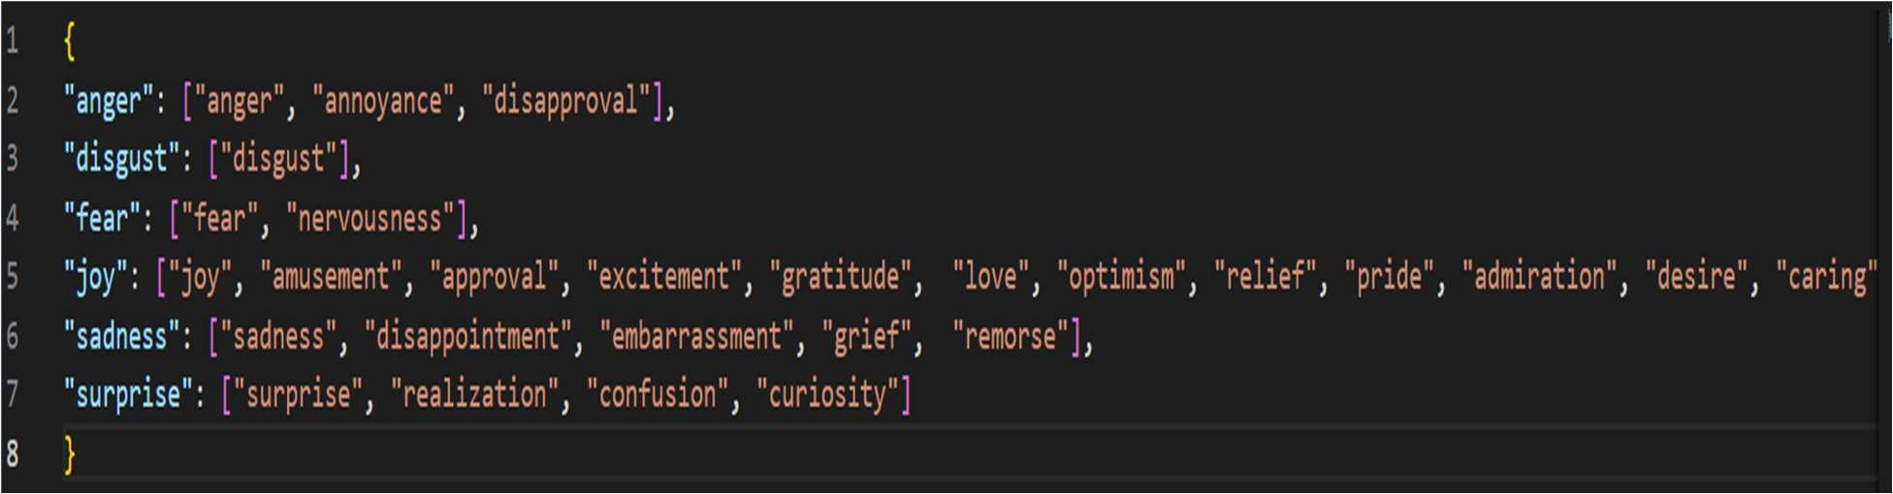

The dataset then, has been changed to the features:

* Text
* ID
* List of classes
* Len of Classes
* Anger
* Fear
* Joy
* Sadness
* Surprise

# **Model Architecture**

BERT and RoBERTa are chosen for their exceptional performance in capturing contextual information. The fine-tuning process involves adapting these models to the specifics of emotion recognition. Tokenization, attention mechanisms, and hyperparameter tuning are discussed in detail to provide transparency in the model architecture**.**

The experimental setup is designed to ensure a fair and systematic evaluation. A grid search approach is employed to optimize hyperparameters, including learning rate, batch size, and the number of training epochs. The dataset is split into training and validation sets to facilitate robust model evaluation**.**

The methodology explicitly addresses challenges specific to emotion recognition, providing insights into how the preprocessing and model fine-tuning strategies overcome issues related to sarcasm and subtle cues.

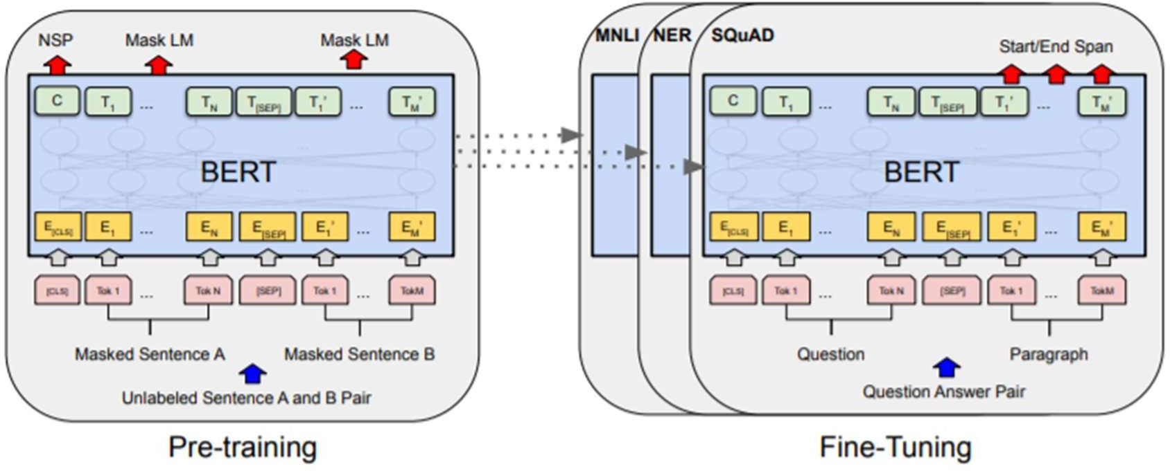

The architecture comprises a BERT-based and a RoBERTa-based model, both followed by a linear layer for multi-label emotion classification. We utilize the AdamW optimizer with a learning rate of 2e-5 for training. Libraries like Beautiful Soup, Emoji, Transformers, TorchVision have been used on the project. Tokenizers of BERT and RoBERTa, Pre-trained Auto Models of BERT and RoBERTa have been used in this implementation.

**Results**

**BERT Model:**

After three epochs of training, the BERT model achieved the following results on the validation set:

* **Accuracy Score:** 75.56%
* **F1 Score (Micro):** 81.92%
* **F1 Score (Macro):** 75.39%

While slightly trailing behind RoBERTa, the BERT model still delivered robust performance, showcasing its capability in understanding and classifying emotional content.

### **RoBERTa Model:**

After three epochs of training, the BERT model achieved the following results on the validation set:

* **Accuracy Score:** 75.56%
* **F1 Score (Micro):** 81.92%
* **F1 Score (Macro):** 75.39%

The RoBERTa model, leveraging a modified architecture with a more dynamic training approach, showcased competitive accuracy and F1 scores. This indicates its effectiveness in capturing the nuanced patterns within the emotional context of the text.

## Comparison and Analysis:

* RoBERTa outperformed BERT in terms of accuracy, F1 scores (both micro and macro), and overall macro- average F1 score.
* Both models had F1 scores more than 75%, indicating strong performance. With the next-sentence prediction aim removed, the RoBERTa model tends to be more computationally efficient. It may be more scalable due to its efficiency, especially in settings with limited resources.
* Training convergence is accelerated by the architecture of RoBERTa. In situations when training time is a crucial consideration, the model may be better since it adjusts to the subtleties of the emotion detection task more rapidly.

***Classification reports for B and RoBERTa Performance***

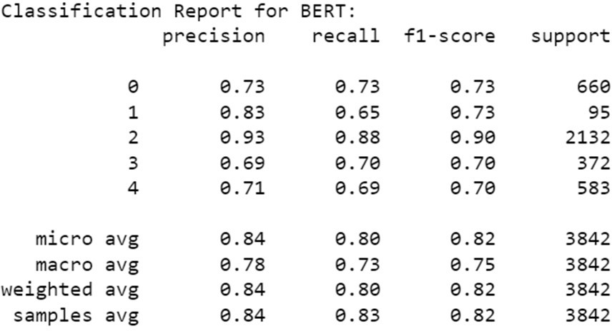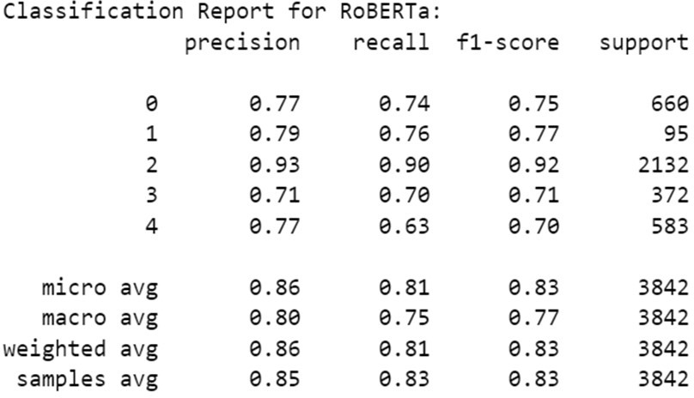

**Below are the ROC Curves for BERT and RoBERTa Performances:**

**BERT: RoBERTa:**

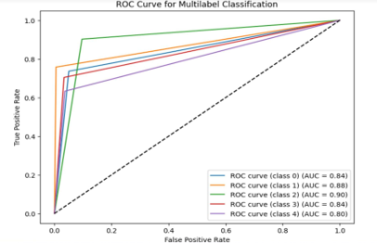

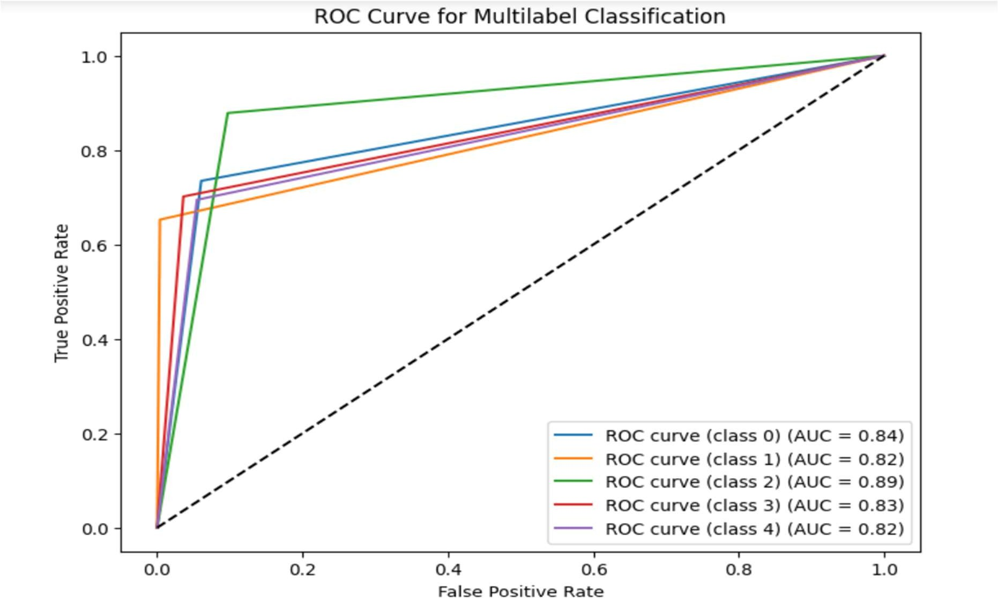

**Conclusion**

The study investigated and proved the effectiveness of text-based emotion recognition utilizing RoBERTa and BERT. Performance was improved by the preprocessing pipeline, which included contraction expansion and spelling correction. Transformer-based models outperformed baselines in their ability to recognize intricate patterns and emotional expressions. ROC curves demonstrated how effective they were. Advanced preprocessing, attention techniques, and domain knowledge transfer are among the upcoming enhancements. Intensity of emotion and user-specific modelling may improve comprehension. By providing insights for a variety of applications, such as sentiment analysis and tailored experiences, this project promotes emotion detection in natural language processing (NLP) and contributes to the continued development of emotion analysis methodologies.

# **References**

1. Chowdhury, G. G. (2003). Natural language processing. Annual Review of Information Science and Technology, 37(1), 51-89. https://doi.org/10.1002/aris.1440370103
2. Acheampong, FA, Wenyu, C, Nunoo-Mensah, H. Text-based emotion detection: Advances, challenges, and opportunities. Engineering Reports. 2020; 2:e12189. https://doi.org/10.1002/eng2.12189
3. Devlin, J., Chang, M., Lee, K., & Toutanova, K. (2019). BERT: Pre-training of Deep Bidirectional Transformers for Language Understanding. North American Chapter of the Association for Computational Linguistics.
4. Liu, Y., Ott, M., Goyal, N., Du, J., Joshi, M., Chen, D., Levy, O., Lewis, M., Zettlemoyer, L., & Stoyanov, V. (2019). RoBERTa: A Robustly Optimized BERT Pretraining Approach. ArXiv, abs/1907.11692.